PROPOSED DISSERTATION TITLE: …………………………….

Student’s Full Name
Student Number
Department
Program

Proposal Submission Date (Month and Year)

Dissertation Supervisor: Title and Full Name
Gebze Technical University

DISSERTATION MONITORING COMMITTEE MEMBERS:

Member : Title and Full Name
University/Institution

Member : Title and Full Name
University/Institution

Member : Title and Full Name
University/Institution

TABLE OF CONTENTS

1. Introduction………………………………………………………………………………......................4
2. Literature Review 4
3. Unique Aspect 4
4. Methods and Techniques To Be Used in the Dissertation Study…………………………………..4
5. Widespread Impact 4
6. Study Budget and Available Research Facilities, Infrastructure, and Equipment……………......4
7. Project Details If the Study Is To Be Supported by a Project (TÜBİTAK, EU, DPT, etc.)…........4
8. Study’s Contribution to the United Nation’s (UN) Sustainable Development Goals (SDGs) 5
9. Time Plan 6
10. References 6

The following headings related to the dissertation need to be addressed within the doctoral dissertation proposal.

INTRODUCTION
The significance of the dissertation, its purpose and objectives must be expressed in separate sections with short and clear sentences.

LITERATURE REVIEW
Studies related to the dissertation topic conducted before in literature and their significance in literature must be discussed.

UNIQUE ASPECT
The hypothesis/hypotheses upon which the dissertation study is built and the unique aspect of the dissertation study must be clearly stated. The novelties and contributions to be introduced to the literature by the new technologies, methods, or the theory that will develop as a result of the proposed dissertation study must be listed and explained in detail.

METHODS OR TECHNIQUES TO BE USED IN THE DISSERTATION STUDY
The proposed/selected methods and research techniques to be applied for the dissertation must be explained in detail, referencing the related literature. Any alternative method(s) planned for in case of any kind of setbacks in the methods to be applied for the dissertation study must also be provided in detail as Plan B.

WIDESPREAD IMPACT
The potential to produce high-quality academic publications and generate new projects as a result of the dissertation must be emphasized. Additionally, contributions to economic, social, and societal well-being must be clearly stated in brief sentences. The expected outputs and results of the study must be outlined, including who can benefit from them and how.

STUDY BUDGET AND AVAILABLE RESEARCH FACILITIES, INFRASTRUCTURE, AND EQUIPMENT
The approximate budget for the proposed study must be provided. A detailed list of available research facilities, infrastructure, and equipment in the academic division where the study will be conducted must be included. The feasibility of the project with the available resources must be examined thoroughly.

PROJECT DETAILS IF THE STUDY IS TO BE SUPPORTED BY A PROJECT (TÜBİTAK, EU, DPT, etc.)
The resources applied for/to be applied to must be clearly stated if it is not going to be possible to carry out the dissertation study using the available infrastructure and resources.

THE CONTRIBUTION OF THE DISSERTATION STUDY TO THE SUSTAINABLE DEVELOPMENT GOALS (SDG) OF THE UNITED NATIONS (UN)
The number of the SDG(s) to which the dissertation study will contribute must be indicated, brief description on each must be provided, whether or not they will be actively implemented within the GTU campus must be indicated (if applicable).
olmayacağı belirtilmelidir. (For detailed information, please visit: https://www.kureselamaclar.org/en)

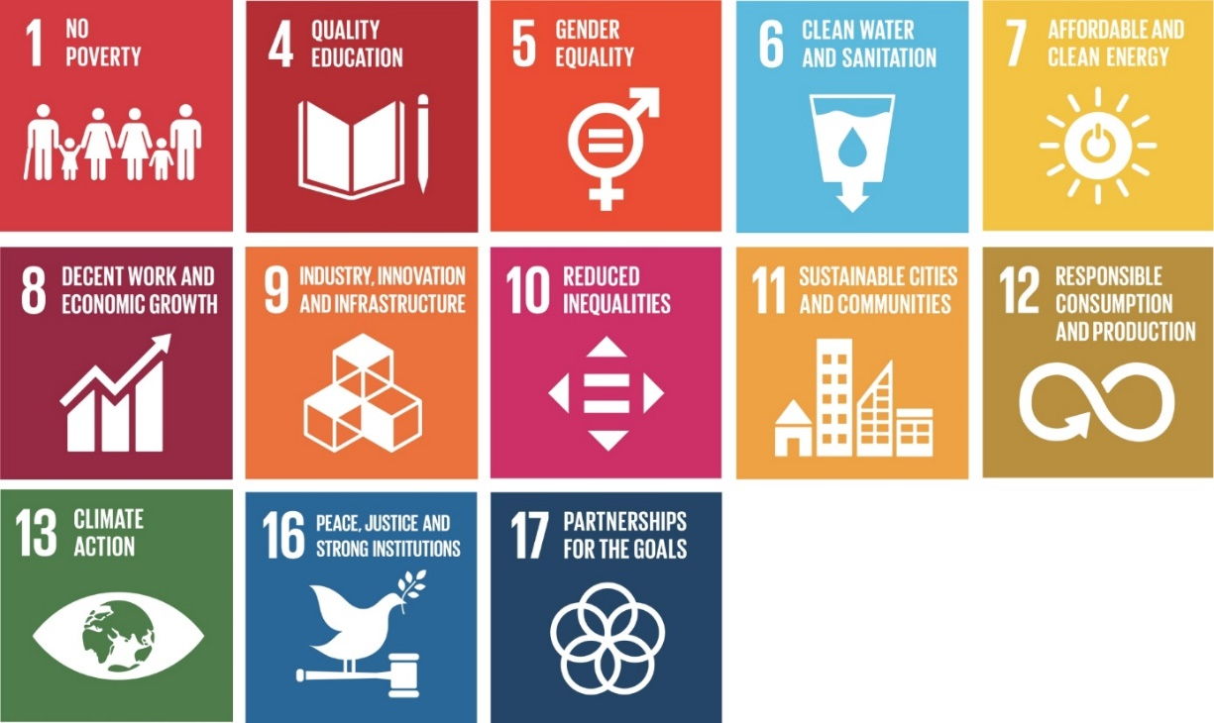

SDG No | Brief Description

TIME PLAN
The work packages and the proposed time plan must be given as a “Work-Time Schedule”. The time planning must be created for periods of 6 months.

REFERENCES
The references must be listed in line with the GTU Graduate Thesis Writing Guide.

WORK-TIME SCHEDULE

Work Package No and Title | Work Package Description
 | Month(s) 0-6 | Months 7-12 | Months 13-18 | Months 19-24 | Months 25-30 | ……

